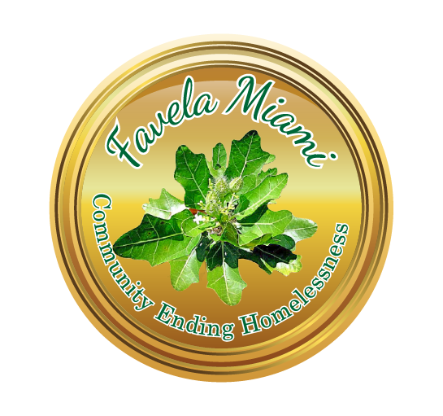
Homeless Services Division
555 17th Street
Miami Beach, FL 33139
Tel: (305) 604-4663
Fax: (305) 604-4094

Referral Form

Name:  Date of Birth:  SS #:  Sex: male female transgender  Contact Information:  Telephone #_______________________________________  Email ____________________________________________ | HMIS #: __________________________  Race:  White Black, AA  Other _____________  Ethnicity:  Hispanic  Non-Hispanic

Shelter/ Housing Services:
- Camillus House  - Chapman Partnership 1  - Chapman Partnership 2  - Lotus House | - Salvation Army – Miami Beach Bed  - Salvation Army – Homeless Trust Bed  - Miami Rescue Mission – Miami Beach Bed  - Miami Rescue Mission – Homeless Trust Bed

Treatment Services:
  - Miami Rescue Mission –Treatment
  - Central Intake Unit – Substance Abuse

Medical Services:
- Camillus Health Concern Clinic  - Douglas Gardens Community Mental Health Ctr.  - Miami Beach Community Health Center | - Borinquen Health  - Jackson Memorial Hospital Triage:  Crisis Detox Medical Attention

Legal Services:
- Legal Services of Greater Miami  - Catholic Charities Legal Services Inc.  - Camillus House | - Social Security Administration  - US Citizenship & Immigration  - Other

Food/Meal Services: |  | Job Employment Services:
- St. Patrick’ Church – Sat 11 – 12pm  - St. Joseph Church – Sat 11 – 12pm  - Temple Beth Shalom - 1st Tues 3:45pm | - Food Stamp Office | - Hope in Miami Dade, Inc.  - CareerSource South Florida,  Miami Beach Center

Other Services:
Community Action Agency
Other:
Other/Comments:
NOTE TO RECIPIENT AGENCY: This referral has been issued by the Office of Homeless Services in order to help the above
mentioned client. We greatly appreciate your assistance in addressing the client’s needs. The agency must immediately notify the
City of Miami Beach of any legal claims that are filed by the client. If you suspect this document may have been altered or tampered
with, please contact us at (305) 604-4663.

Staff Signature: Date:

Beckham Hall | 2735 NW 10th Ave, Miami, FL 33127 (305) 634-2294
Better Way of Miami, Inc. | 800 NW 28th. St., Miami, FL.33127 (305) 634-3409
Camillus Health Clinic | 336 NW 5th Street, Miami, FL 33128 (305) 374-1065
Camillus House Shelter | 726 NE 1st Ave, Miami, FL 33132 (305) 374-1065
Carrfour Supportive Housing | 222 71st Street, Miami Beach, FL 33141 (305) 756-722
Catholic Charities Legal Services Inc. | 150 SE 2nd Ave. #200, Miami, Florida (305) 373-073
Central Intake Unit | 2500 NW 22 Ave. Miami, Florida 33142 (305) 638-6540
Citrus Health Network, Inc. | 4175 W 20th Avenue, Hialeah, FL 33012-5875 (305) 825-0300
Community Action Agency | 833 6th Street, Miami Beach, FL 33139 (305) 672 1705
Comprehensive Health Center | 650 NW 120th St. North Miami, FL 33168 (305) 688-0811
Douglas Gardens Community Mental Health Center | 701 Lincoln Road, Miami Beach, FL (305) 531-5341
Chapman Partnership 1 | 1550 N. Miami Avenue, Miami, FL 33136 (305) 329-3000
Chapman Partnership 2 | 28205 SW 125th Ave., Homestead, Fl. 33033 (305) 416- 7146
Jackson Memorial Hospital: | 1600 NW 10th Avenue, Miami, Fl 33136  Hotline (305) 324-4357 Crisis (305) 355-7377
Jewish Community Services – Job Placements | 1436 Pennsylvania Ave, Miami Beach, FL 33139 (305) 672-466
Legal Services of Greater Miami | 3000 Biscayne Blvd., Miami, FL 33137 (305) 576-0080
Lutheran Services – Housing Services | 16201 SW 95th Avenue, Suite 300, Miami, FL 33157  (305) 969-8700
Miami Beach Community Health Center (MBCHC) | 710 Alton Road, Miami Beach, Fl. 33139 (305) 538-8835
Miami Beach Hispanic Community Center | 1701 Normandy Dr., Miami Beach, Fl 33141 (305) 867-051
Miami Rescue Mission | 2020 NW 1st Ave., Miami, FL 33127 (305) 571-2211
Mother Teresa – Missionaries of Charity | 724 NW 17th Street, Miami, FL 33136 (305) 326-0032
New Horizon | 1313 NW 36th Street, Miami, FL 33142 (305) 635-0366
One Stop Career Center / MBHCC | 833 6th Street, 2. Floor Miami Beach, FL 33139 (305) 532-350
Riverside House, Substance Abuse | 968 Northwest 2nd Street, Miami, Florida 33128 (305) 545-8292
Salvation Army | 1907 NW 38th Street, Miami, FL 33142 (305) 637-6720
St. Joseph’s Church  (Food Saturday only 09:00 am – 12:00 pm) | 8670 Byron Avenue, Miami Beach, FL 33141 (305) 866-6567
St. Patrick’s Church  (Food Saturday only 09:00 am -12:00 pm) | 3716 Garden Avenue, Miami Beach, FL 33140 (305) 531-124
Temple Beth Shalom  ( First Tuesday of every month at 3:00 pm) | 4144 Chase Avenue, Miami Beach, FL 33140 (305) 538-7231
Transition Inc. | 1550 NW 3rd Ave. Miami, FL 33128 (305) 374-1987
US Citizenship & Immigration | 7880 Biscayne Boulevard, Miami, Florida 33138 1-800-375-283
US Social Security Administration | 1801 Alton Road Suite 200, Miami Beach, FL 33139  (305) 538-704 or 1-800-772-213
Volunteers of America – Supportive Housing | 1492 W. Flagler Street Miami, FL 33135 (305) 644-0335
Miami Beach Community Development Corp. (MBCDC) | 542 Jefferson Ave., Miami Beach, Fl. 33139 (305)535-8002

